Gun Range + Horse Riding
A balanced mix of adrenaline and scenic beauty.
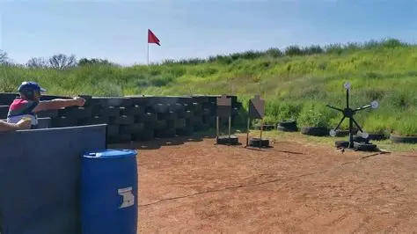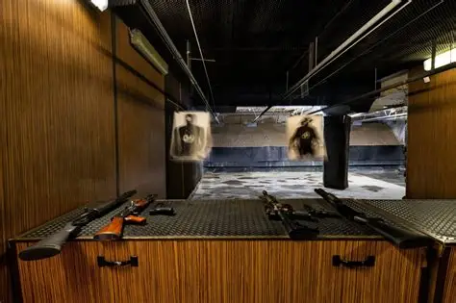
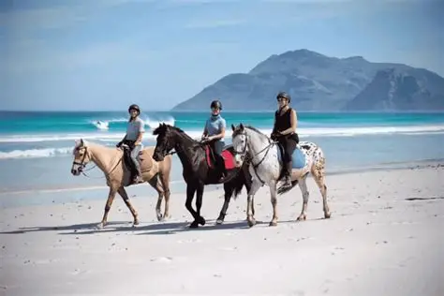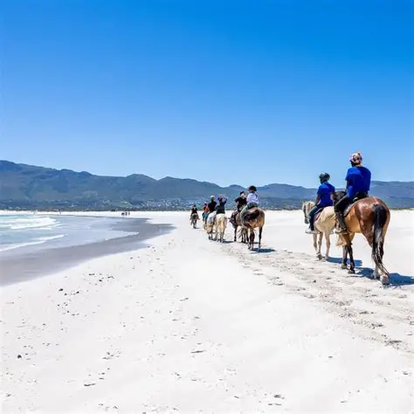
Tour Overview
Enjoy a shooting session at a certified range, then relax with a peaceful horse ride along Noordhoek Beach.
Itinerary
- Pickup in Cape Town
- Shooting range session
- Chapman’s Peak scenic drive
1–2 hour Noordhoek Beach horse ride
Return to Cape Town
Inclusions
- Private transport
- Shooting range session
- Horse riding
- Safety equipment
- Bottled water on route
Exclusions
Meals
Price
2–4 guests: R10,260 total
5–7 guests: R14,200 total

